Ali Tarraf

Ali Al-mugoter

Hassan Harajly

Jeremy Jones

Mohamed Fawaz

**80% Code 20% Thought**

**Term Project:**

**Chocoholics Anonymous**

**Problem Statement:**

Chocoholics Anonymous currently handles all data manually. Providers have to manually log all information about their visits and manually verify member status. We will create software to stream line the process to make it more efficient for the organization as a whole. We will do this by creating a data center for all relevant parties to access data.

**Entity Relationship Diagram:**

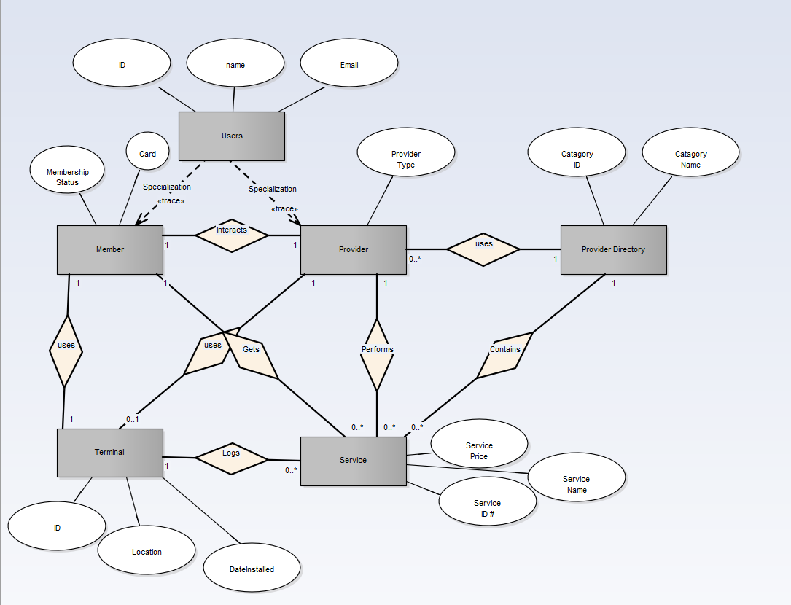

**Current State:**

The current state of the company consists of several components, Provider, Provider Directory, Member, Service, and a provider Terminal. The Provider will give services to ChocAn members. Currently the company is inefficient due to the provider having to keep their own recorders about patient services rendered as well as what occurred during the visit and what service was rendered, and the provider currently has to manually bill for all services rendered instead of an automated process. Provider will manually email the member every week a receipt of the services rendered. The receipt has a break down of the services, prices, date. The provider will do all this manually.

**Future State:**

In the future state we plan to add a data center to the current state. The data center will connect to the terminal to verify a members’ number. During the day the Data Center is run in an interactive mode which will allow operators to add or remove members, and update member records. The Provider records are also added, deleted, or updated during this time. The Acme computer will update any relevant ChocAn Data Center computer membership records in the evening. To add this component to the current state we will need to connect the Data Center to the Terminals. We will also need to add a manager and give them access to the data center. Acme will verify if the member account is still active and up to date on payments, if not the Provider will be notified through the terminal that the member has a suspended account. Acme is responsible for suspending and renewing memberships depending on member account balance. Another required component is the Electric Funds Transfer which makes sure the Providers bank account is credited with the appropriate amount.